

**MINISTRY OF HEALTH AND FAMILY WELFARE**

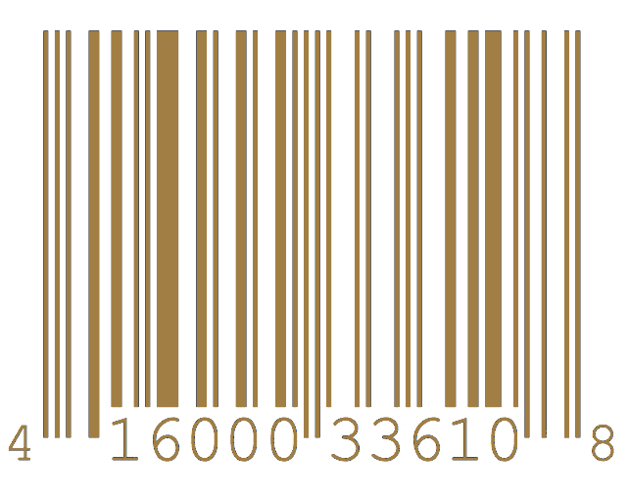

Government of India

Certificate of Virtual Checkup

T H I S E L E C T R O N I C H E A L T H C H E C K U P I S P R E S E N T E D T O



FARHAN HAI KHAN

Radiologist Department of Biotechnology

N. Misra

NIRMALYA MISRA

Automation Engineer AI Cell

Damik Dhar

Coronavirus Scale : 01.41 % Automated Tests : Passed Manual Tests : Passed.

Comments : Fit for Travel.

# UID(Aadhaar) : 8456-7894-1245

Certificate ID : 9572-4168-4320

F. H. Khan